

Software Development Specification

Phase 2

# Document Control

|  |  |  |  |
| --- | --- | --- | --- |
| Version | Description | Author | Date |
| 0.1 Draft | First Draft | Mike Varley | 11/11/17 |
| 1.0 | Updated with feedback from Kishor. Ready for development. | Mike Varley | 13/11/17 |
|  |  |  |  |
|  |  |  |  |
|  |  |  |  |

# Distribution

|  |  |  |  |
| --- | --- | --- | --- |
| Name | Role | Organisation |  |
| Kishor Mistry | CAU Partner | CAU |  |
| Mikhail | Contract Developer |  |  |
|  |  |  |  |
|  |  |  |  |

# Contents

Document Control 2

Distribution 2

Contents 3

Introduction 4

Objectives and Scope 4

Functional Requirements 5

Data Load 5

Screen Layout 5

Search (No change) 5

Results 5

Filtering & Sorting 6

Hyperlinks (No Change) 6

Access & Security 6

Non-Functional Requirements 7

Platforms 7

Performance 7

Appendices 8

1. Phase 1 8

2. Data Load File Definitions 9

2.1 Unique Keys 9

2.2 CAU-ORGANISATIONS 9

2.3 KIS-COURSE (Selected Fields) 10

2.3 CAU-COURSE-FACTS 12

2.3 KIS AIM 14

2.4 KIS COURSESTAGE 14

3. Front Page 15

4. Technical Design 15

# Introduction

A basic CAU web site is in operational in a test environment but only displays up to 6,000 records and has significant performance issues.

The web site needs now to be upgraded so that it performs at a usable level on the full 37,000 course records and displays a more comprehensive set of data items.

# Objectives and Scope

The objectives of Phase 2 are to:

* Build on the Phase 1 development (See screen shots in appendices)
* Display the full 37,000+ course records
* Provide the required level of performance
* Change some of the data items displayed
* Make some refinements to the display layout

# Functional Requirements

## Data Load

1. Load up the following files (defined in the appendices):
   1. CAU-ORGANISATIONS
   2. KIS-COURSE
   3. CAU-COURSE-FACTS
   4. KIS-AIM
   5. KIS-COURSE-STAGE

## Screen Layout

1. The horizontal scroll bar should be visible at all times (not off the screen as at present on long results lists)

## Search (No change)

No change at this stage

## Results

1. Display the following data items ordered as below from left to right:
   1. EducationProvider.Name
      1. Column Heading: “Uni/College”
   2. Course.Name
      1. Column Heading: “Course”
   3. Course.Code (CAU Course Facts)
      1. Column Heading: “UCAS Code”
   4. Course.Qualification
      1. Column Heading: “Qual.”
      2. Use Course.QualificationCode and look up QualificationName in KISAIM
   5. Course.Duration
      1. Column Heading: “Years”
      2. See Duration Calculation Rules in appendices
   6. Course.StudyMode
      1. Column Heading: “Mode”
      2. Display values defined in appendices
   7. Course.TypicalOffer (CAU Course Facts)
      1. Column Heading: “Typical Offer”
   8. Course.StudyAbroad
      1. Column Heading: “Study Abroad”
      2. Display values defined in appendices
   9. Course.Sandwich
      1. Column Heading: “Work Placement”
      2. Display values defined in appendices
   10. EducationProvider.NationalRanking
       1. Column Heading: “UK Uni Ranking”
   11. EducationProvider.WorldRanking
       1. Column Heading: “World Uni Ranking”
   12. EducationProvider.Group
       1. Column Heading: “Group”
   13. Course.Exams
       1. Column Heading: “Exam%”
   14. Course.Coursework
       1. Column Heading: “CourseWork%”
   15. Course.Contact
       1. Column Heading: “Contact%”
   16. Course.SuccessScore (CAU Course Facts)
       1. Column Heading: “Success”
   17. Course.SatisfactionLevel (CAU Course Facts)
       1. Column Heading: “Satisfaction”
       2. Display values defined in appendices
   18. Course.EntryStandardsLevel (CAU Course Facts)
       1. Column Heading: “Entry Standards”
       2. Display values defined in appendices
   19. Course.CAURating (CAU Course Facts)
       1. Column Heading: “CAU Rating”

## Filtering & Sorting

The existing functionality should be applied as defined below.

1. Allow filtering on:
   1. Organisation Name
   2. Qualification
   3. Group
   4. Duration
   5. Study Mode
   6. Study Abroad
   7. Work Placement
2. Allow Sorting on:
   1. National Uni Ranking
   2. World Uni Ranking
   3. Success Score
   4. Satisfaction
   5. Entry Standards
   6. Exam%
   7. CourseWork%
   8. Contact%

## Hyperlinks (No Change)

Retain existing Uni and Course level hyperlinks at this stage

## Access & Security

1. Provide access to the search screen via a password protected “front page” (see appendices) from the urls : [www.ChooseaUni.com](http://www.ChooseaUni.com) and [www.ChooseaUni.co.uk](http://www.ChooseaUni.co.uk)
2. Display direct access from <http://www.chooseauni.com/search.html>

# Non-Functional Requirements

## Platforms

1. Software should be “responsive” and work on all devices (PCs, Tablets and Mobile Phones) and screen sizes
2. Software should work on all common browsers

## Performance

1. The search result experience on the 37,000+ record file should be the same as the experience on the original Phase 1 200 record JSON file (i.e. instantaneous).

# Appendices

## Phase 1

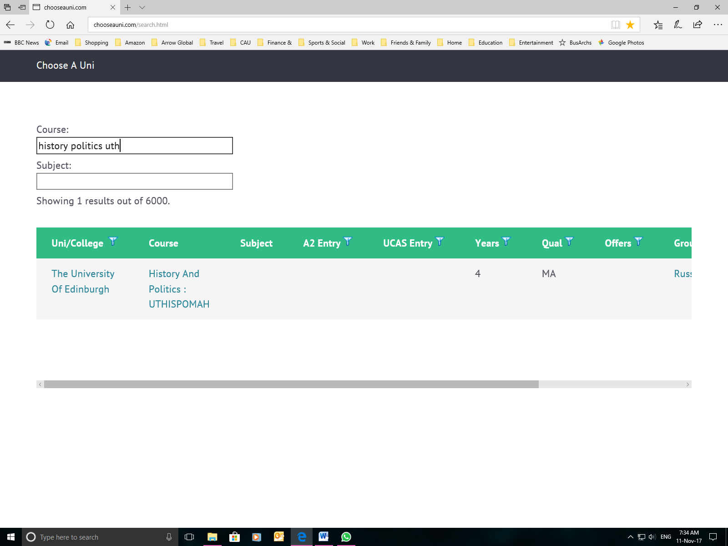

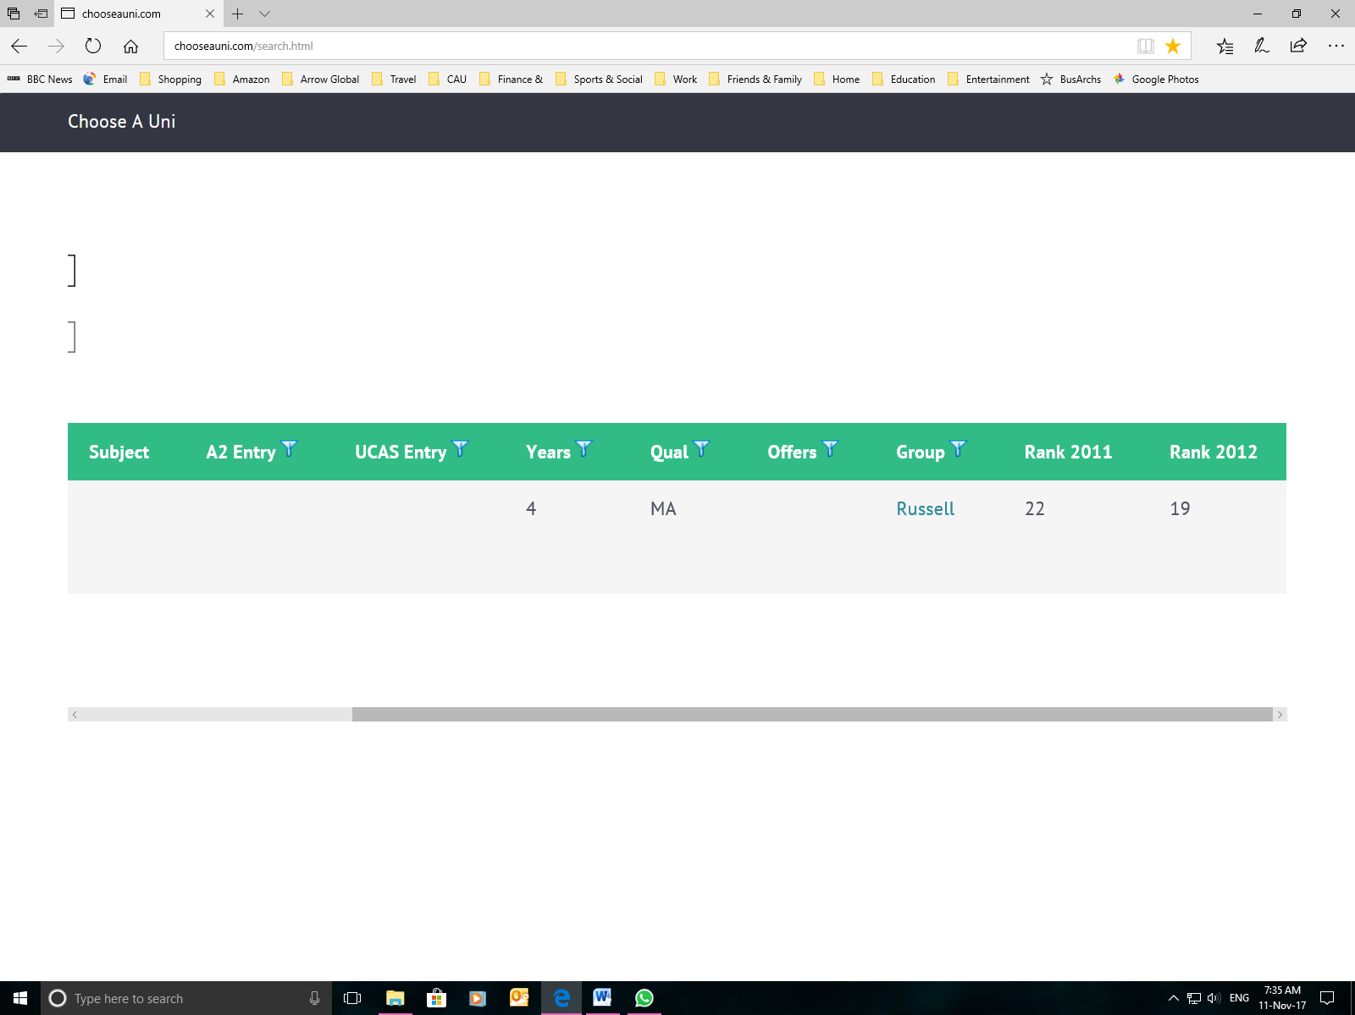

## Data Load File Definitions

### 2.1 Unique Keys

**Education Provider**

Education Provider Id: e.g. 10006840 (Birmingham)

**Course**

Education Provider Id: e.g. 10006840 (Birmingham)

Course Id: K0331

Study Mode Id: 1=Full Time 2=Part Time 3= Both

Example Unique Course Identifier on CAU database: 10006840-K0331-1

These keys are only unique whilst we have only one Admissions System in CAU (i.e. UK UCAS). If we have other countries then we will need to add an Admissions System identifier (e.g. UCAS) to the start of the keys to keep them unique.

### 2.2 CAU-ORGANISATIONS

| Data Item | Description | Format | Source | Source Field Name | Search List Display Rules | Valid Values and Example |
| --- | --- | --- | --- | --- | --- | --- |
| Education Provider | | | | | | |
| Reference Number | Unique within Admissions System (in the UK this is UCAS) | N8 | Unistats UKPRN Lookup | UKPRN | No | Birmingham = 10006840 |
| Name | Full legal name | Char 255 | Unistats: UKPRN Lookup | NAME | On hover over displayed Short Name | The University of Birmingham |
| Short Name | Abbreviation that can be used on displays and reports | Char 8 | WIKIPEDIA | SHORT NAME | Yes | OXF, EDINB, LANC, NEWC |
| Code |  | Char 3 | UCAS | CODE | No | Birmingham = B32 |
| Group | The academic group to which the University belongs (e.g. Russell Group) | Char 8 | Web Sites  <http://www.russellgroup.ac.uk/about/our-universities/> | GROUP | Yes | Russell or Blank |
| National Ranking | Out of more than 100 in the UK | N4 | Guardian Web Site | RANKING | Yes |  |
| World Ranking | Out of more than 800 | N4 | QS Web Site | WORLD-RANKING | Yes |  |
|  |  |  |  |  |  |  |

### 2.3 KIS-COURSE (Selected Fields)

| Data Item | Description | Format | Source | Source Field Name | Search List Display Rules | Valid Values and Example | |
| --- | --- | --- | --- | --- | --- | --- | --- |
| Course | | | | | | |
| Education Provider Identifier | Unique id of the Education Provider within the UK UCAS Admissions System. Internal use only. Not displayed to users. | N8 | Unistats: KISCOURSE | UKPRN | No | Birmingham = 10006840 | |
| URL | Hyperlink to Course Web Site.  Right click the Course Name and select the “Go to Course Web Site” option | Char 255 | Unistats: KISCOURSE | CRSEURL | Right click on Course.Name to see a list of actions, one of which is “View Course Web Page” |  | |
| Foundation | Course includes an integrated foundation year | Char 1 | Unistats: KISCOURSE | FOUNDATION | 0 = Blank  1 = “Optional”  2 = “Compulsory” | 0 = Not Available  1 = Optional  2 = Compulsory | |
| Honours | Honours Degree availability | Char 1 | Unistats: KISCOURSE | HONOURS | 0 = Blank  1 = “Hons” | 0 = Not Honours  1 = Honours | |
| Identifier | Part of unique course UCAS course key:  UKPRN+KISCOURSEID+  KIS MODE. Internal use only. Not displayed to users. | Char 30 | Unistats: KISCOURSE | KISCOURSEID | No | H300UMMEENEN-SW-MENG | |
| Study Mode | Full time or Part Time | Char 1 | Unistats: KISCOURSE | KISMODE | 0 = Blank  1 = “Full Time”  2 = “Part Time”  3 = “Full or Part” | 0 = Not Available  1 = Optional  2 = Compulsory  3 = Both | |
| Type | The type of course course record. This needs more analysis but type 3 records have already been excluded in data prep because they do not have a course name | Char 1 | Unistats: KISCOURSE | KISTYPE | No | 1 – 3  Needs further analysis to understand these fully | |
| Sandwich | Course includes a year work placement | Char 1 | Unistats: KISCOURSE | SANDWICH | 0 = Blank  1 = “Optional”  2 = “Compulsory” | 0 = Not Available  1 = Optional  2 = Compulsory | |
| Name | The name/title of the course | Char 255 | Unistats: KISCOURSE | TITLE | Yes | English & Philosophy | |
| Year Abroad | Course includes an additional year studying abroad  In addition some universities offer the opportunity to study abroad for a full year in year 2 or a semester of year 2. This does not extend the study by a year. | Char 1 | Unistats: KISCOURSE | YEAR ABROAD | 0 = Blank  1 = “Optional”  2 = “Compulsory” | 0 = Not Available  1 = Optional  2 = Compulsory | |
| Qualification Code | A code that indicates the qualification on successful completion of the course. Links to Qualification Name that has been added to this file | Char 3 | Unistats: KISCOURSE | KIS AIM CODE | No | 0 = BA | |
| Exams | Proportion of the assessment of the full course that is assessed by written exam. Note that the year proportions are likely to vary. | NNN% | Unistats: KISCOURSE | AVG WRITTEN | Yes | Integer % | |
| Coursework | Proportion of the assessment of the full course that is assessed by coursework. Note that the year proportions are likely to vary. | NNN% | Unistats: KISCOURSE | AVG COURSE WORK | Yes | Integer % | |
| Contact | Average time in lectures and tutorials over the full duration of the course. Note that the year proportions are likely to vary. | NNN% | Unistats: KISCOURSE | AVG SCHEDULED | Yes | Integer % | |

### 2.3 CAU-COURSE-FACTS

| Data Item | Description | Format | Source | Source Field Name | Search List Display Rules | Valid Values and Example | |
| --- | --- | --- | --- | --- | --- | --- | --- |
| Course | | | | | | |
| Education Provider Identifier | Unique id of the Education Provider within the UK UCAS Admissions System. Internal use only. Not displayed to users. | N8 | Unistats: KISCOURSE | UKPRN | No | Birmingham = 10006840 | |
| Identifier | Part of unique course UCAS course key:  UKPRN+KISCOURSEID+  KIS MODE. Internal use only. Not displayed to users. | Char 30 | Unistats: KISCOURSE | KISCOURSEID | No | H300UMMEENEN-SW-MENG | |
| Study Mode | Full time or Part Time | Char 1 | Unistats: KISCOURSE | KISMODE | 0 = Blank  1 = “Full Time”  2 = “Part Time”  3 = “Full or Part” | 0 = Not Available  1 = Optional  2 = Compulsory  3 = Both | |
| Code | The code used to identify the course when applying to the admissions administrator | Char 4 | UNKNOWN. Not found a source for this yet. On a temporary basis the user can click through to the course web site to obtain this information and make a note of it manually. | Code | Yes | QV35 | |
| Satisfaction Score | A guide to how satisfied students are with the quality of this course | NNN% | Unistats: NSS. Derived from NSS using a multi-step manual data prep process to calculate satisfaction scores at course (rather than subject) level | Satisfaction Score | Yes | Integer % | |
| Satisfaction Level | Derived from Satisfaction Score. Classifies the score 1-5 (Very High to Very Low) in equal 20% bands.  This field will be dropped from the data load file in the future when the CAU system automatically calculates classifications. | N1 | CAU | Satisfaction Classification | 5 = Very High  4 = High  3 = Medium  2 = Low  1 = Very Low | 1-5 or Blank | |
| Success Score | Proportion of students that received a 1st of 2:1  The percentage of graduates achieving a first or upper second class honours degree on this course.  Maximum score: 100.0 | NNN% | Unistats: DEGREECLASS  Derived manually in data prep from DegreeClass.UFIRST and DegreeClass.UUPPER | Success Score | Yes | Inger % | |
| Typical Offer | Initially, if available, the basic 3 A Level Grade Requirements (later we can aim to add others such as Scottish Highers) | Char 10 | UNKNOWN. Not found a source for this yet. On a temporary basis the user can click through to the course web site to obtain this information and make a note of it manually. | Required Grades | Yes | AAA | |
| Entry Standards Score | A score calculated by CAU that represents the entry standards of existing students on the course. The higher the number the higher the standards.  Note: Where course level information was not available this value as been derived from subject level information. | N3 | Unistats: Tariff  Look at prototype V2 tabs  Derived from Tariff information. See Data prep procedure for details. | Entry Standards Score | Yes | Typically in the range 0 - 250 | |
| Entry Standards Level | Derived from Entry Standards Score. Classifies the score 1-5 (Very High to Very Low) in equal 20% bands.  This field will be dropped from the data load file in the future when the CAU system automatically calculates classifications. | N1 | CAU | Satisfaction Classification | 5 = Very High  4 = High  3 = Medium  2 = Low  1 = Very Low | 1-5 or Blank | |
| Subject Ranking | The national (e.g. UK) subject ranking or average subject ranking in the case of combined honours | N4 | Download from Guardian Web Site: <https://www.theguardian.com/education/2016/may/23/the-guardian-university-guide-2017-download-tables-in-full> | Subject Ranking | Yes |  | |
| CAU Rating | Proprietary rating (future requirement) | N4 |  | CAU Rating | Yes | TBD | |

### 2.3 KIS AIM

| Data Item | Description | Format | Source | Source Field Name | Search List Display Rules | Valid Values and Example | |
| --- | --- | --- | --- | --- | --- | --- | --- |
| Qualification | | | | | | |
| Code | 3 digit key for qualification | N3 | KISAIM | KISAIMCODE |  |  | |
| Name | Qualification Name (e.g. BA or BSC) | Char20 | KISAIM | KISAIMLABEL |  |  | |
|  |  |  |  |  |  |  | |

### 2.4 KIS COURSESTAGE

| Data Item | Description | Format | Source | Source Field Name | Search List Display Rules | Valid Values and Example | |
| --- | --- | --- | --- | --- | --- | --- | --- |
| Course Stage | | | | | | |
|  |  |  | COURSESTAGE | PUBUKPRN |  |  | |
|  |  |  | COURSESTAGE | UKPRN |  |  | |
|  |  |  | COURSESTAGE | KISCOURSE ID |  |  | |
|  |  |  | COURSESTAGE | KISMODE |  |  | |
|  |  |  | COURSESTAGE | ASSACT |  |  | |
|  |  |  | COURSESTAGE | COURSEWORK |  |  | |
|  |  |  | COURSESTAGE | INDEPENDENT |  |  | |
|  |  |  | COURSESTAGE | LTACT |  |  | |
|  |  |  | COURSESTAGE | PLACEMENT |  |  | |
|  |  |  | COURSESTAGE | PRACTICAL |  |  | |
|  |  |  | COURSESTAGE | SCHEDULED |  |  | |
|  |  |  | COURSESTAGE | STAGE |  |  | |
|  |  |  | COURSESTAGE | WRITTEN |  |  | |

In the COURSESTAGE.CSV file each row represents a year of study. Count the number of stages per unique course (KISCOURSEID) per education provider (UKPRN) and course mode (KISMODE)

*Excel column rule: KISCOURSE.COURSESTAGE=COUNTIF(UKPRN&KISCOURSEID&KISMODE, STAGE)*

*Also doing a MAX on COURSESTAGE.STAGE no returned rows achieves the same.*

## Front Page

Use this screen as the entry point from [www.ChooseaUni.com](http://www.ChooseaUni.com) and [www.ChooseaUni.co.uk](http://www.ChooseaUni.co.uk)

A password should be added to this screen. Only allow access to the search screen following password entry.



## Technical Design

